
Name: Ali Raza
Reg no: 9864
CS412 Natural Language Processing, Assignment 2, Fall 2026
Instructor: Hafiz Muhammad Farhan
Due date: 04 November 2026

Title: Intelligent Complaint Routing for the Islamabad Municipal Helpdesk

Department of Computing, Islamabad Campus
Program: BS Computer Science

Integrity Declaration

I declare that this assignment is my original work, that CLO-mapped tasks were
performed by me, and that any third-party code or AI assistance is acknowledged.

Signature: ______________________ Date: ______________

Introduction

The Islamabad Municipal Helpdesk (IMH) receives citizen complaints in English, Urdu script and Roman Urdu, often mixed in one sentence, and operators currently read every ticket by hand and forward it to Electricity, Water, Sanitation, Traffic, Health or Other. This report builds a classical NLP pipeline for the helpdesk, without Transformers or LLM APIs, in four steps: (A) representing the noisy text with Bag-of-Words and TF-IDF, (B) routing each ticket to a department with Naive Bayes and a Linear SVM, (C) highlighting people, places and organisations with spaCy and a rule layer, and (D) extracting a who-did-what structure from the dependency parse. Part E evaluates the results, recommends whether to deploy, and discusses ethics. The data are the 40 labelled tickets in imh_complaints.csv, which is a very small set, so every result below should be read with that limit in mind. The work was done in Python 3.14 with pandas, scikit-learn (1.9.1), spaCy (3.8.16, model en_core_web_sm 3.8.0), matplotlib and seaborn, entirely on CPU.
Table 1 Class distribution of the 40 tickets:
Department | Tickets
Electricity | 9
Water | 8
Sanitation | 7
Traffic | 6
Health | 6
Other | 4
Total | 40

A1 Preprocessing

The dataset contains 40 tickets written in English, Roman Urdu or a mix of both. Before building a representation, I applied nine steps in this order: Unicode (NFKC) normalisation, replacement of URLs, CNIC numbers and phone numbers with placeholder tokens, removal of emojis, lowercasing, protection of sector codes such as G-10/3 and G-9, and cleaning of extra spaces.
Table 2 Before and after preprocessing for three tickets
Ticket | Before (raw) | After (cleaned)
IMH-001 | Bijli nahi aa rahi Sector G-9 Islamabad mein last 8 hours se. IESCO helpline does not pick the call. | bijli nahi aa rahi sector g9 islamabad mein last 8 hours se. iesco helpline does not pick the call.
IMH-002 | No water in Street 7 F-11 since Monday. CDA tanker never comes to our block. | no water in street 7 f11 since monday. cda tanker never comes to our block.
IMH-008 | Meter reader from IESCO overcharged our house in G-10/3. Bill is 45000 which is impossible. | meter reader from iesco overcharged our house in g10_3. bill is 45000 which is impossible.

Table 1 shows that the cleaning rules change only what is needed: the text is lowercased, and sector codes such as G-9, F-11 and G-10/3 are rewritten as single tokens (g9, f11, g10_3), while ordinary words and Roman Urdu phrases stay exactly as the citizen wrote them.

I deliberately kept several features of the raw text. Sector and street codes such as G-9, F-11, I-8 and G-10/3 were protected rather than removed, because they identify where the problem is and are therefore strong signals for routing. The default scikit-learn tokenizer splits "G-9" into "G" and "9" and then discards both, because it ignores one-character tokens, so I rewrote these codes as single tokens before vectorising. Roman Urdu words such as "bijli" and "kachra" were left unchanged, and I lowercased the text only because Roman Urdu carries no useful capitalisation. I did not remove stopwords: no standard stopword list covers Roman Urdu, and with only 40 short tickets every word that might carry department information was worth keeping. Numbers such as 45000 (a bill amount) and 1122 (the ambulance service) were also kept, since they are not personal identifiers.
I searched the 40 raw tickets with regular expressions for URLs, emojis, Pakistani mobile numbers and CNIC-like numbers. The search found 0 URLs, 0 emojis, 0 phone numbers and 0 CNIC-like numbers, so none of the real tickets needed redaction. To check that the rules work, I tested them on three synthetic examples that I wrote myself (Table 2). Phone numbers are replaced by the token "phonetok", CNIC numbers by "cnictok" and URLs by "urltok", and emojis are removed. These tokens are placeholders so that sensitive values never reach the model.
Table 3 Synthetic examples of sensitive-pattern handling
Before (synthetic example) | After (cleaned)
Bijli band hai, call 0300-1234567 ya CNIC 61101-1234567-1 | bijli band hai, call phonetok ya cnic cnictok
Details: https://example.com/complaint?id=9 G-9 mein pani nahi | details: urltok g9 mein pani nahi
Meter reading galat hai IESCO ko 03451234567 par call kiya | meter reading galat hai iesco ko phonetok par call kiya

These three examples are synthetic, so they show that the rules function correctly, not that the real data contains sensitive values.

A2. BoW and TF-IDF

Both representations were built on the same cleaned corpus with scikit-learn, using unigrams and bigrams (ngram_range = (1, 2)) and otherwise default settings, so the only difference between them is the weighting: CountVectorizer stores raw word counts, while TfidfVectorizer weights each term by its frequency in the ticket and its rarity across the 40 tickets. Both produce a 40 x 902 matrix, and since the zeros are in the same positions, the vocabulary size and sparsity are identical.

Table 4 Size and sparsity of the two representations
Representation | Shape (tickets x terms) | Vocabulary size | Sparsity
Bag-of-Words | 40 x 902 | 902 | 96.90%
TF-IDF (unigrams + bigrams) | 40 x 902 | 902 | 96.90%

Table captions below list the ten highest-weighted TF-IDF terms for one Electricity ticket (IMH-008) and one Water ticket (IMH-016).

Table 5 Top ten TF-IDF terms for an Electricity and a Water ticket
Rank | IMH-008 (Electricity) | Weight | IMH-016 (Water) | Weight
1 | reader from | 0.200 | in f8 | 0.191
2 | reader | 0.200 | muddy | 0.191
3 | overcharged our | 0.200 | f8 | 0.191
4 | overcharged | 0.200 | stomach pain | 0.191
5 | meter reader | 0.200 | stomach | 0.191
6 | our house | 0.200 | water from | 0.191
7 | which is | 0.200 | drinking water | 0.191
8 | which | 0.200 | pain | 0.191
9 | is impossible | 0.200 | drinking | 0.191
10 | is 45000 | 0.200 | plant in | 0.191

I also computed the cosine similarity between TF-IDF vectors of ticket pairs. Two Electricity tickets (IMH-001 and IMH-019) had a similarity of 0.034 and two Water tickets (IMH-002 and IMH-011) had 0.127, whereas an Electricity and a Sanitation ticket (IMH-001 and IMH-009) had 0.000. Over all pairs, the mean similarity was 0.027 within the same department and 0.014 across different departments.
Table 6 Cosine similarity between ticket pairs
Ticket pair | Departments | Cosine similarity
IMH-001 vs IMH-019 | Electricity / Electricity | 0.034
IMH-002 vs IMH-011 | Water / Water | 0.127
IMH-001 vs IMH-009 | Electricity / Sanitation | 0.000
All same-department pairs (mean) |  | 0.027
All different-department pairs (mean) |  | 0.014

IMH-001 and IMH-019 share only two terms, "hours" and "iesco".
The sparsity of 96.90% means that 96.90% of the cells in the 40 x 902 matrix are zero: each ticket is short and uses only a small fraction of the vocabulary, so most terms never appear in any given ticket. All ten top terms for IMH-008 have the same weight (0.200) because each of these phrases occurs exactly once and appears in no other ticket, so TF-IDF gives them identical scores. This also shows that in a corpus this small, TF-IDF rewards rare phrases rather than words that actually signal a department, such as "iesco". The same-department mean similarity (0.027) is about twice the different-department mean (0.014), which suggests a weak signal, but both values are close to zero, which means that even tickets from the same department share very few terms. A similarity of 0.000, as for IMH-001 and IMH-009, means that the two tickets have no term in common.

A3. Representation Chosen

I chose TF-IDF as the representation for Part B. Unlike Bag-of-Words, which counts every word equally, TF-IDF down-weights terms that appear in many tickets, such as "the" and "in", so rarer words count for more. Part A also showed its limits on a corpus of only 40 tickets. All ten top terms for IMH-008 had the same weight (0.200) because each phrase occurs in one ticket only, so TF-IDF favours rare phrases over words such as "iesco" that actually signal a department. Same-department tickets also share very few terms (mean cosine similarity 0.027, against 0.014 across departments).
Both representations can fail on Roman Urdu. The words "bijli" and "electricity" mean the same thing, but for TF-IDF they are two unrelated features, because it matches strings and knows nothing about meaning. A citizen who writes "bijli nahi aa rahi" therefore shares no vocabulary with one who writes "no electricity". Only a few tickets use Roman Urdu (for example IMH-001 and IMH-015), so the model sees these words too rarely to learn them.
Character n-grams would help with spelling variants of Roman Urdu words, but they cannot link "bijli" to "electricity". A small Roman Urdu-to-English normalisation table could, so I propose combining both as a next-sprint improvement.

B1 Protocol

The 40 tickets were divided into a training set of 28 and a test set of 12 using a stratified 70/30 split (random_state = 42), so that every department appears in both parts in roughly the same proportion. The seed is fixed so that anyone who re-runs the notebook obtains exactly the same split and results. Each model is a scikit-learn Pipeline made of a TF-IDF vectoriser (unigrams and bigrams) followed by a classifier. Because the vectoriser is inside the pipeline, its vocabulary and IDF weights are learned from the training tickets only, which prevents information from the test tickets leaking into the model. I compared Multinomial Naive Bayes (default smoothing, alpha = 1.0) with a Linear SVM (LinearSVC, C = 1.0). Because one ticket changes the accuracy on a 12-ticket test set by about 8 percentage points, I also ran shuffled, stratified 4-fold cross-validation on all 40 tickets (same seed, vectoriser refitted inside every fold). I used four folds because the smallest class, Other, has only four tickets.

Table 7 Class counts in the 12-ticket test set
Department | Test tickets
Electricity | 3
Health | 2
Sanitation | 2
Traffic | 2
Water | 2
Other | 1

B2 Metrics and Confusion Matrices

Table 5 reports accuracy, precision, recall and F1 (macro and weighted averages) for both models, on the 12-ticket test split and under 4-fold cross-validation.

Table 8 Performance of Naive Bayes and Linear SVM
Setting | Model | Accuracy | Macro P | Macro R | Macro F1 | Weighted P | Weighted R | Weighted F1
70/30 split (12 tickets) | Naive Bayes | 0.417 | 0.156 | 0.333 | 0.208 | 0.206 | 0.417 | 0.271
70/30 split (12 tickets) | Linear SVM | 0.667 | 0.486 | 0.583 | 0.498 | 0.549 | 0.667 | 0.570
4-fold CV (40 tickets) | Naive Bayes | 0.375 | 0.18 | 0.29 | 0.21 | 0.22 | 0.38 | 0.26
4-fold CV (40 tickets) | Linear SVM | 0.475 | 0.35 | 0.40 | 0.36 | 0.39 | 0.47 | 0.41

Table 9 Per-class results of the Linear SVM (4-fold CV)
Department | Precision | Recall | F1 | Support
Electricity | 0.64 | 1.00 | 0.78 | 9
Health | 0.33 | 0.17 | 0.22 | 6
Other | 0.00 | 0.00 | 0.00 | 4
Sanitation | 0.14 | 0.14 | 0.14 | 7
Traffic | 0.50 | 0.33 | 0.40 | 6
Water | 0.50 | 0.75 | 0.60 | 8

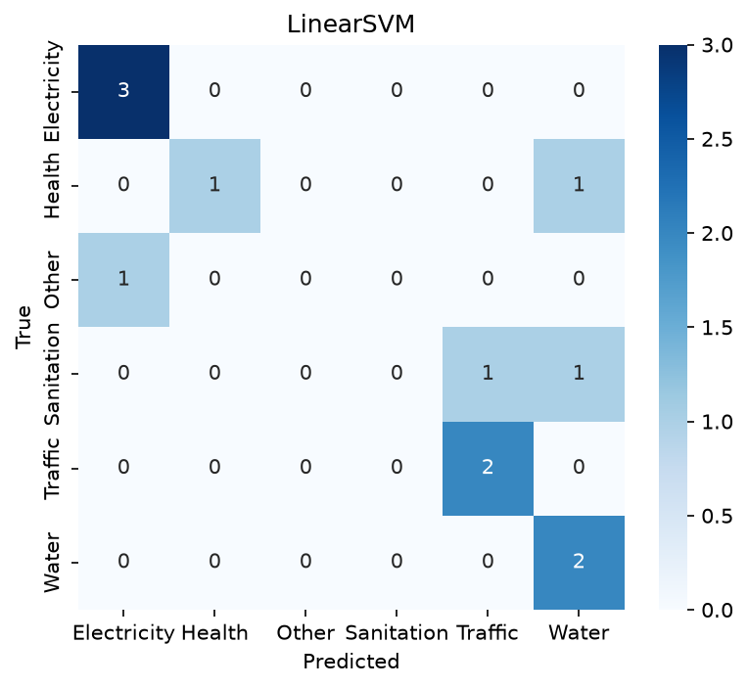
Figure 1 Confusion matrix of Linear SVM on the 12-ticket test split
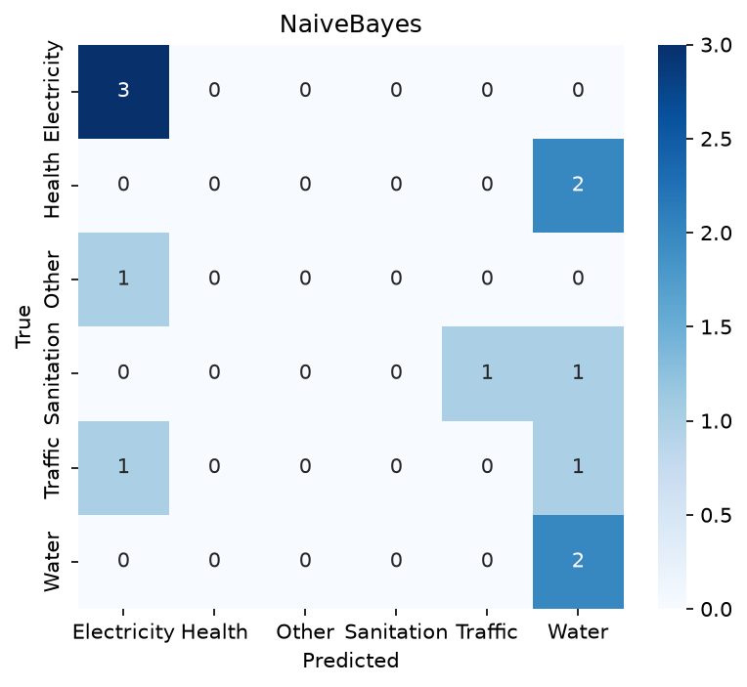
Figure 2 Confusion matrix of Naive Bayes on the 12-ticket test split

On the 12-ticket test split the Linear SVM reached an accuracy of 0.667 and Naive Bayes 0.417, but this comparison is fragile: one ticket changes the accuracy by about 8 percentage points. Under 4-fold cross-validation on all 40 tickets the figures drop to 0.475 for the SVM and 0.375 for Naive Bayes. Because the cross-validated estimate uses every ticket, I trust it more than the split, and I read the SVM's 0.667 as a favourable draw rather than its real performance. Even 0.475 is low, since more than half of the tickets would still be misrouted.
The class imbalance is visible in the per-class results. The department Other, which has only four tickets, receives an F1 score of 0.00: it is defined as "anything that does not fit", so its tickets share no vocabulary that a linear model could learn, and in cross-validation all three of its misclassified tickets that were routed to a specific department went to Electricity. Naive Bayes shows the same problem more strongly: in cross-validation it predicted only three departments (Electricity 28 times, Water 8 and Sanitation 4), so its macro F1 (0.21) lies well below the weighted F1 (0.26), because the weighted average hides the departments it never predicts.
Sanitation is the department that is confused most often: it is involved in 12 of the 21 errors of the cross-validated SVM. The most frequent pair is Health and Sanitation (4 errors), followed by Sanitation and Water, and Sanitation and Traffic (3 each). One example from the test split, misclassified by both models, is IMH-009 (gold: Sanitation, predicted: Traffic): "Sewerage overflow outside Faisal Mosque parking. Children from nearby school are falling sick." The vocabulary learned from the 28 training tickets contained only five of its words (are, faisal, from, parking, school); words such as "sewerage", "overflow", "mosque" and "sick" were never seen, and "parking" is among the strongest Traffic features of the SVM. The model therefore had almost no Sanitation evidence in this ticket and relied on the one word that points to Traffic. This is an out-of-vocabulary problem as much as a model problem.

B3. Naive Bayes versus Linear SVM

Across 4-fold cross-validation the two models gave different answers on 14 of the 40 tickets (Table 10). On all 14, Naive Bayes predicted Electricity, although none of these tickets belongs to Electricity. The SVM was right on four of them (IMH-012, IMH-027, IMH-031 and IMH-038) and wrong on ten. This accounts for the whole gap between the 19 tickets the SVM routed correctly and the 15 routed correctly by Naive Bayes, since the two models agree on every other ticket.

Table 10 Tickets on which Naive Bayes and Linear SVM disagreed (4-fold CV)
Ticket | Gold | Naive Bayes | Linear SVM | SVM correct
IMH-005 | Traffic | Electricity | Water | No
IMH-006 | Health | Electricity | Sanitation | No
IMH-009 | Sanitation | Electricity | Traffic | No
IMH-012 | Traffic | Electricity | Traffic | Yes
IMH-013 | Health | Electricity | Water | No
IMH-017 | Traffic | Electricity | Health | No
IMH-018 | Sanitation | Electricity | Health | No
IMH-022 | Water | Electricity | Traffic | No
IMH-026 | Health | Electricity | Water | No
IMH-027 | Traffic | Electricity | Traffic | Yes
IMH-031 | Sanitation | Electricity | Sanitation | Yes
IMH-032 | Health | Electricity | Sanitation | No
IMH-036 | Sanitation | Electricity | Water | No
IMH-038 | Health | Electricity | Health | Yes

This behaviour is consistent with the independence assumption of Naive Bayes. The classifier multiplies the probabilities of all words given a class as if the words were independent, and with only 3 to 7 training tickets per department and a vocabulary of 902 terms, these probabilities are estimated from very few observations. In cross-validation Naive Bayes predicted Electricity 28 times, against 9 true Electricity tickets, and it never predicted Traffic, Health or Other. Changing the smoothing parameter shows that smoothing plays a part: with alpha = 1.0, 0.3, 0.1 and 0.01 the number of Electricity predictions fell to 28, 16, 11 and 7 (Table 11). For two tickets (IMH-027 and IMH-038) I checked the mechanism directly (see below); I have not done so for all 14 tickets, so I regard the explanation as established for these two examples and as likely, but not proven, for the rest.
Table 11 Effect of the smoothing parameter on Naive Bayes 4-fold CV, diagnostic only
alpha | CV accuracy | Times Electricity was predicted
1.0 (default, used in this report) | 0.375 | 28
0.3 | 0.375 | 16
0.1 | 0.425 | 11
0.01 | 0.400 | 7

IMH-027 ("Traffic police blocked the I-8 underpass during peak hours.") was routed to Traffic by the SVM and to Electricity by Naive Bayes. To see why, I retrained both models on the other 39 tickets. Only six terms of this ticket were in the vocabulary (hours, the, i8, police, traffic and the bigram "traffic police"); words such as "blocked", "underpass" and "peak" had never been seen. For Naive Bayes these terms favoured Traffic over Electricity by a total of 0.16 log-units, but the class prior favoured Electricity by 0.58 (nine of the 39 tickets are Electricity and five are Traffic), so Electricity won. The SVM relied on the same three terms, "police", "traffic" and "traffic police", but it won only narrowly: its scores for Traffic and Electricity were -0.445 and -0.507.
IMH-038 ("Ambulance from 1122 took 40 minutes to reach Bhara Kahu. The operator said no vehicle was free.", gold: Health) shows the opposite case: when both models were retrained on the other 39 tickets, the SVM was right and Naive Bayes was wrong. In cross-validation Naive Bayes had predicted Electricity for this ticket and now it predicted Water, so its answer changes with the training set. Again only six terms of the ticket were in the vocabulary (from, no, reach, the, to, was); "ambulance", "1122", "operator" and "vehicle" had never been seen. For Naive Bayes these six terms favoured Health over Water by only 0.05 log-units, while the class prior favoured Water by 0.47 (eight of the 39 tickets are Water and five are Health), so Water won. The SVM scored Health -0.465 and Water -0.573. Its deciding term was "was" (+0.288 for Health), which occurs in several Health training tickets (IMH-006, IMH-020 and IMH-026), while "reach" pulled towards Water (-0.169), probably because it occurs in a Water ticket (IMH-011). The SVM therefore reached the right department mainly through function words that happen to occur in Health tickets, not through words that describe health care, so a correct prediction here is weak evidence that it is the better model.
A linear SVM instead chooses weights that separate the classes with the largest possible margin and does not assume that words are independent. In sparse, high-dimensional text such as this (902 features for 40 tickets) the classes can often be separated by a few discriminative terms, which is the situation in which a margin-based classifier tends to work well. The evidence for "the SVM is better" is nevertheless limited. It routes four more tickets correctly than Naive Bayes (19 against 15 of 40), it also over-predicts Electricity (14 times against 9 true tickets) and Water (12 against 8), and it never predicts Other. The smoothing parameter was varied on the same cross-validation data, so the 0.425 obtained with alpha = 0.1 is not a fair estimate and I kept the default value in the comparison. With 40 tickets I cannot claim that the difference would hold on new data.

C1 spaCy plus a Rule Layer

I ran the spaCy model en_core_web_sm (version 3.8.0) on the raw text of every ticket, without lowercasing, because the model relies on capital letters to recognise names. Its labels were mapped to the three types of the task: PERSON to PER, GPE, LOC and FAC to LOC, and ORG to ORG; DATE, TIME and other types were ignored. Because the model does not know Pakistani sector codes or local organisations, I added a layer of regular expressions for organisations (IESCO, CDA, PIMS, FGSH, WASA, and BHU followed by a place name) and for locations (sector codes such as G-9, G-10/3 or I-8 Markaz, optionally preceded by "Sector", and "Street" or "House" followed by a number). Where a rule match overlaps a spaCy span, the rule replaces the spaCy span. I wrote these rules after reading the same 40 tickets that are used for evaluation in C2, so the scores of the combined system are optimistic and not a held-out estimate.
Table 12 NER output before and after the rule layer
Ticket and gold entities | Before (spaCy only) | After (spaCy + rules)
IMH-001: Sector G-9 (LOC), Islamabad (LOC), IESCO (ORG) | Bijli nahi aa rahi (PER), G-9 Islamabad (LOC), helpline (LOC) | Bijli nahi aa rahi (PER), Sector G-9 (LOC), IESCO (ORG), helpline (LOC)
IMH-018: PIMS (ORG) | none | PIMS (ORG)
IMH-029: Ahmed Khan (PER), House 14 (LOC), Street 9 (LOC), G-11 (LOC), IESCO (ORG) | Ahmed Khan (PER), House (ORG) | Ahmed Khan (PER), House 14 (LOC), Street 9 (LOC), G-11 (LOC), IESCO (ORG)

C2. Scores and Errors

I scored both systems against the gold_entities column, which I treat as a silver standard. A prediction counts as correct only if both the text and the type (PER, LOC or ORG) match a gold entity exactly, ignoring case, so "G-9" does not match "Sector G-9". DATE entities in the gold file were not scored, because the task asks for PER, LOC and ORG only. The gold file contains only five PER entities, so the PER scores are very unreliable.

Table 13 Exact-match scores against gold_entities
System | Type | TP | FP | FN | Precision | Recall | F1
spaCy only | PER | 2 | 14 | 3 | 0.125 | 0.400 | 0.190
spaCy only | LOC | 13 | 5 | 34 | 0.722 | 0.277 | 0.400
spaCy only | ORG | 9 | 11 | 12 | 0.450 | 0.429 | 0.439
spaCy only | All | 24 | 30 | 49 | 0.444 | 0.329 | 0.378
spaCy + rules | PER | 2 | 13 | 3 | 0.133 | 0.400 | 0.200
spaCy + rules | LOC | 34 | 4 | 13 | 0.895 | 0.723 | 0.800
spaCy + rules | ORG | 18 | 7 | 3 | 0.720 | 0.857 | 0.783
spaCy + rules | All | 54 | 24 | 19 | 0.692 | 0.740 | 0.715

Adding the rules raised the micro F1 from 0.378 to 0.715, mainly because location recall rose from 0.277 to 0.723 and organisation recall from 0.429 to 0.857. These figures should not be read as the expected performance on new tickets. The rules were written after reading the same 40 tickets that are used for scoring, so some of the gain reflects fitting to this data set, and the true figures on unseen tickets would be lower. The gold file also contains only five PER entities, so the PER scores (F1 0.200) say very little.
The first true error is that place names are tagged as persons. In both systems, Rawalpindi (IMH-006), Bari Imam (IMH-014), Ali Pur (IMH-026), Peshawar Morr (IMH-030) and Bhara Kahu (IMH-038) were labelled PER although the gold label is LOC. For example, in IMH-026 ("Dengue spray was not done in Ali Pur this month. Last year we had 9 cases.") the model labelled "Ali Pur" as a person, probably because it is a capitalised name that the model does not recognise as a place. My rules do not cover these names, so the error remains. Together with phrases such as "Bijli nahi aa rahi" and "kachra wala nahi" (Roman Urdu), and everyday nouns such as "bill", "meter" and "nullah", this makes PER the least reliable type: of 15 PER predictions only 2 are correct (precision 0.133).
The second true error is a flaw of my own overlap rule. In IMH-001 spaCy produced one span, "G-9 Islamabad". My rule matched "Sector G-9", and because the two overlap, the whole spaCy span was discarded, so "Islamabad", which is a correct gold LOC, was lost. In the spaCy-only output this entity was not scored correctly either, since the span did not match exactly, but the rule layer removed any chance of recovering it. A better rule would trim the overlapping span and keep the remainder. Some other differences are annotation conventions rather than model errors: the gold file has "E-11" where the text says "Sector E-11" (IMH-021), and "Sara Bibi" where the text says "Ms Sara Bibi" (IMH-032), so exact matching counts these as an error and a miss at once.
I would not ship this NER to the control room as an automatic component, but I would use it as a highlighter under human supervision. Locations and organisations are reasonably reliable (precision 0.895 and 0.720), whereas persons are not (precision 0.133). The condition is that the clerk always sees the highlights as suggestions that can be edited, that PER highlights are shown only after the clerk confirms them, and that no routing or action is triggered by an entity. Recall is 0.740, so about one entity in four is missed and the clerk must still read the ticket. Before deployment the rules should be tested on new tickets that were not used to write them, because the present scores are optimistic.

Error type | Tickets | Detail
Place names tagged PER | IMH-006, 014, 026, 030, 038 | Rawalpindi, Bari Imam, Ali Pur, Peshawar Morr, Bhara Kahu
Facility names tagged ORG, gold LOC | IMH-009, 023, 025 | Faisal Mosque, Diplomatic Enclave, Karachi Company
Roman Urdu phrases tagged PER | IMH-001, 015 | Bijli nahi aa rahi, kachra wala nahi
Honorific in the span | IMH-032, 040 | Ms Sara Bibi vs Sara Bibi, Mr Bilal vs Bilal
Entity lost by my overlap rule | IMH-001 | Islamabad
Inconsistent gold | IMH-021 | gold is E-11, text says Sector E-11

D1. Dependency Parses and Constituency Sketches

I parsed the five required sentences with spaCy (en_core_web_sm 3.8.0), which produces dependency parses with the labels nsubj, ROOT, dobj, prep, pobj, det, compound, amod and punct (spaCy's scheme uses prep and pobj where the task text mentions obl). spaCy does not produce constituency trees, so I wrote the constituency sketches (NP, VP, PP) by hand from the noun chunks and the dependency trees. Figure 1 shows the rendered dependency parses and Table 12 gives the sketches.

Table 14 Constituency sketches of the five sentences
Ticket | Constituency sketch
IMH-004 | (S (NP (NP The residents) (PP of (NP G-9))) (VP submitted (NP a complaint) (PP about (NP the transformer))))
IMH-011 | (S (NP CDA water tanker) (VP did not reach (NP Street 12) (NP yesterday)))
IMH-018 | (S (NP Someone) (VP dumped (NP medical waste) (PP behind (NP PIMS hostel))))
IMH-027 | (S (NP Traffic police) (VP blocked (NP the I-8 underpass) (PP during (NP peak hours))))
IMH-033 | (S (S (NP IESCO staff) (VP replaced (NP the meter))) but (S (NP billing) (VP is (ADVP still) (ADJP wrong))))

Figure 3 Dependency parse of IMH-004 (spaCy)
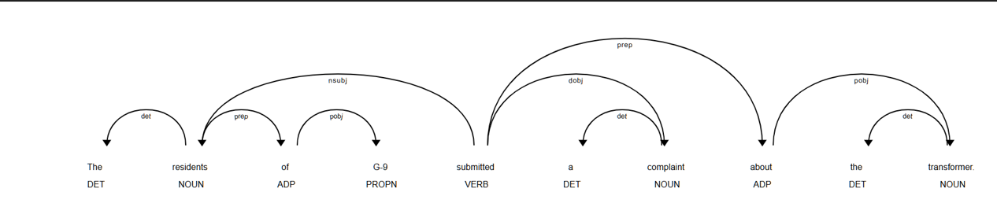

Figure 4 Dependency parse of IMH-011 (spaCy)
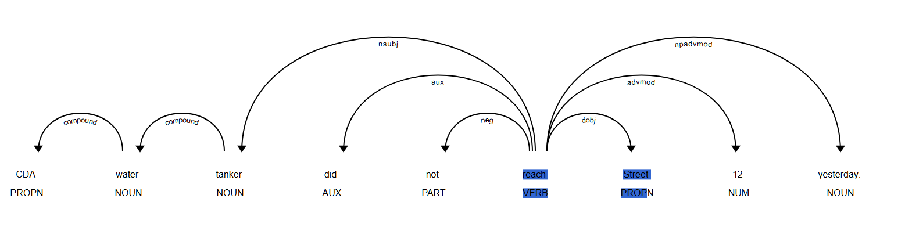

Figure 5 Dependency parse of IMH-018 (spaCy)

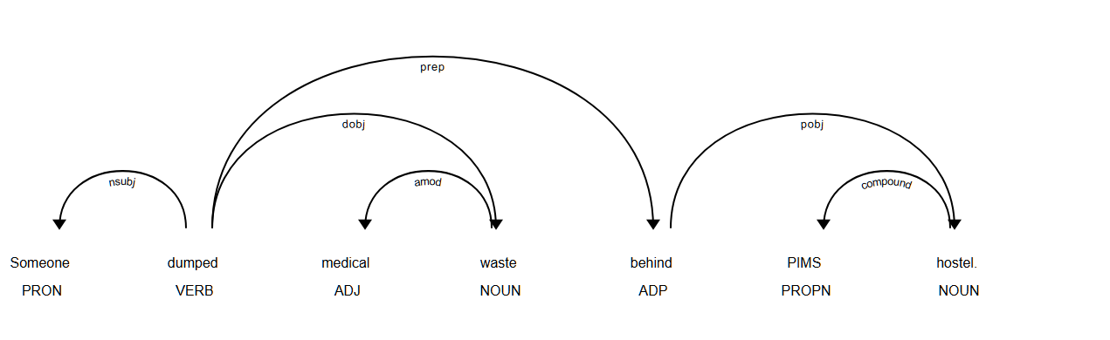

Figure 6 Dependency parse of IMH-027 (spaCy)
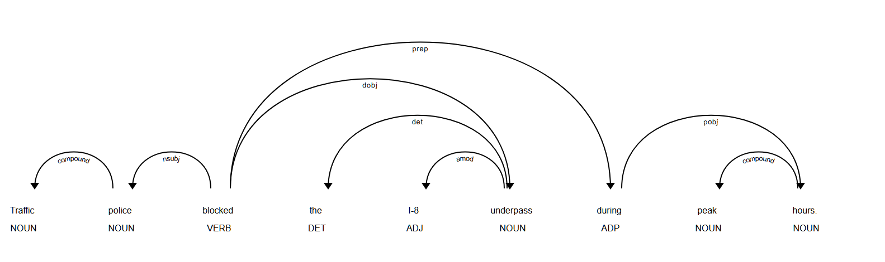

Figure 7 Dependency parse of IMH-033 (spaCy)
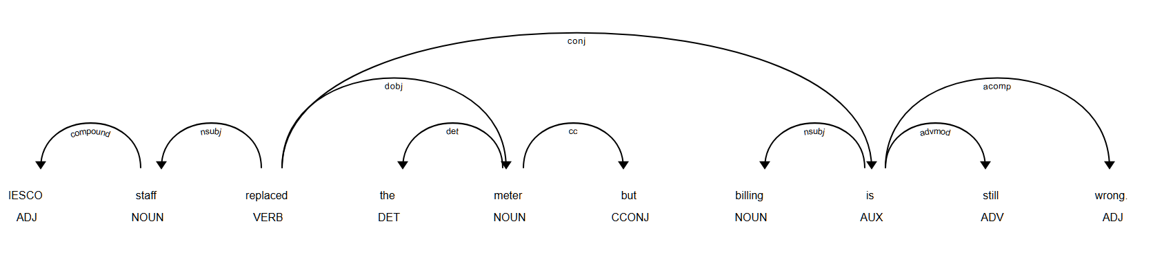

Table 15 Triples (subject, predicate, object/location): parser output and corrected

Ticket | Parser output | Corrected
IMH-004 | (The residents of G-9, submitted, a complaint), about the transformer | (residents of G-9, submitted, complaint about the transformer)
IMH-011 | (CDA water tanker, did not reach, Street), time: yesterday | (CDA water tanker, did not reach, Street 12), time: yesterday
IMH-018 | (Someone, dumped, medical waste), behind PIMS hostel | same
IMH-027 | (Traffic police, blocked, the I-8 underpass), during peak hours | same
IMH-033 | (IESCO staff, replaced, the meter but) and (billing, is, wrong) | (IESCO staff, replaced, the meter) and (billing, is, still wrong), linked by "but"

In IMH-011 the parser labelled "Street" as dobj and "12" as advmod, so the automatically extracted object was "Street", and a supervisor reading the triple would not learn which street was meant. In IMH-033 the conjunction "but" was attached to "meter" and ended up inside the object of the first triple. These parsing errors therefore reach the output of the product feature.

D2: UAS aur LAS

I chose IMH-027 ("Traffic police blocked the I-8 underpass during peak hours.", 10 tokens including the full stop) and prepared a gold annotation of head and label for each token. I decided the verb "blocked" (root), its subject "police", its object "underpass" and the label of "I-8" myself; the remaining tokens were annotated by applying standard rules (determiners and compounds attach to their noun, "during" is a preposition attached to the verb with "hours" as its object), with help from an AI assistant (see Appendix A). I wrote this annotation after I had seen the parser output, so it is not independent of it. UAS = (tokens with the correct head) / N and LAS = (tokens with the correct head and label) / N. The parser found the correct head for all 10 tokens, so UAS = 10/10 = 1.000. It also gave the correct label for 9 of them, so LAS = 9/10 = 0.900. The one difference is "I-8" (token 4): the parser labelled it amod (adjective), while I labelled it compound, because "I-8" is the name of a sector and works like a noun modifier. LAS can never exceed UAS, since a token needs the correct head and the correct label to count. A single sentence of ten tokens is far too small to say how good the parser is, and this sentence is one of the easier ones.

Token | Parser head | Gold head | Parser label | Gold label | Match
Traffic | police | police | compound | compound | Yes
police | blocked | blocked | nsubj | nsubj | Yes
blocked | blocked | blocked | ROOT | ROOT | Yes
the | underpass | underpass | det | det | Yes
I-8 | underpass | underpass | amod | compound | Label differs
underpass | blocked | blocked | dobj | dobj | Yes
during | blocked | blocked | prep | prep | Yes
peak | hours | hours | compound | compound | Yes
hours | during | during | pobj | pobj | Yes
. | blocked | blocked | punct | punct | Yes

IMH-004 contains a genuine attachment ambiguity. In "The residents of G-9 submitted a complaint about the transformer", the phrase "about the transformer" can modify the noun "complaint" (a complaint concerning the transformer) or the verb "submitted" (submitted something with respect to the transformer). The parser attached it to the verb. Both readings are grammatical, so I do not call this an outright error. In my own reading I attach it to "complaint", because "complaint about X" is a common pattern in which "about" introduces the subject of the complaint, and the sentence is about what the residents complained of, not about how they submitted it. The attachment matters for the product: with the parser's reading, the triple is (residents, submitted, complaint) with "about the transformer" as a loose extra phrase, whereas with my reading the object itself carries the subject of the complaint, "complaint about the transformer", which is the information a supervisor needs.

E1 Error Analysis

Class imbalance. The department Other has only four tickets and receives an F1 of 0.00 with the cross-validated SVM, since it means "anything that fits nowhere" and shares no vocabulary. Naive Bayes predicted only three of the six departments in cross-validation, so its macro F1 (0.21) is far below what accuracy suggests. Sanitation is involved in 12 of the SVM's 21 cross-validated errors, and Health and Sanitation are confused most often (4 errors).

Code-mixing. Tickets such as IMH-001 ("Bijli nahi aa rahi ...") and IMH-015 ("Kachra wala nahi aaya ...") mix Roman Urdu and English. The vectoriser treats "bijli" and "electricity" as unrelated terms, and spaCy tagged "Bijli nahi aa rahi" and "kachra wala nahi" as persons.

Out-of-vocabulary words. With 28 training tickets, many words of a new ticket are unseen. In IMH-020 only eight words were in the vocabulary, mostly function words such as "and" and "was" (plus "women"), while "doctor", "lady", "bhu" and "koral" were unknown. In IMH-009 the words "sewerage", "overflow", "mosque" and "sick" were unknown, so the model most likely relied on "parking".
NER boundary errors. In IMH-001 my overlap rule discarded the span "G-9 Islamabad" and lost "Islamabad". Exact matching also penalises "Ms Sara Bibi" against the gold "Sara Bibi" (IMH-032), "Mr Bilal" against "Bilal" (IMH-040) and "Sector E-11" against "E-11" (IMH-021).

Parsing failure. In IMH-011 the parser labelled "12" as an adverb and "Street" as the object, so the extracted triple lost the street number. In IMH-033 "but" was attached to "meter", and it ended up inside the object of the triple.

Next-sprint improvement. I would combine a small keyword layer with TF-IDF, aimed at the most frequent confusion, Health versus Sanitation: clear Health words (hospital, patient, doctor, dengue, ambulance) and clear Sanitation words (garbage, sewerage, nullah) would add features or override a low-confidence prediction. Tickets such as IMH-018 ("medical waste behind PIMS hostel") contain words of both kinds, so the rules need a priority order and must be tested on new tickets, not on these 40, to avoid the same over-fitting as in C2.

E2 Memo

To: Director, Islamabad Municipal Helpdesk
From: Ali Raza (Reg. no. 9864), student consultant, CS412
Subject: Should the v1 complaint-routing system be deployed?
Recommendation: do not deploy v1 as an automatic router for all tickets. Deploy it as a pilot in which only the most confident predictions are routed automatically and every other ticket goes to the human queue.

Evidence. On the 40 labelled tickets the best model, a Linear SVM, routed 19 correctly (47.5%) in cross-validation; Naive Bayes routed 15 (37.5%). Used on every ticket, v1 would misroute more than half of them.

Threshold. The SVM score is a margin, not a probability. In cross-validation the highest score of each ticket ranged from -0.546 to -0.005, so no ticket scored above 0, and a rule such as "confidence above 0.75" would have routed none of them automatically. I therefore ranked tickets by score. Routing automatically only the top 20% of tickets (8 of 40, score of at least -0.273) gave 7 correct (87.5%); the top 40% (16 tickets) gave 11 correct (68.8%); all tickets gave 47.5%. About one ticket in five would therefore be routed automatically, and four in five would still be read by a clerk.
Limits of this evidence. The thresholds were chosen on the same 40 tickets that measure them, and eight tickets are far too few to prove 87.5%. I recommend measuring the same figure on the first few hundred new tickets before widening the share routed automatically.

Operational risk. Health and Sanitation were the most frequently confused pair (4 of 21 errors), and with all tickets routed automatically three Health tickets went to Sanitation. A ticket about an ambulance, dengue or a hospital waiting in a sanitation queue can lose hours. In the top 20% this did not occur, but eight tickets cannot guarantee it, so I suggest that every ticket labelled Health or Sanitation is checked by a clerk before dispatch.

Entities. The name and place highlighter should be used only as a clerk's aid: locations and organisations are fairly reliable (precision 0.90 and 0.72) but persons are not (0.13).

Next steps. (1) Add a Roman Urdu normalisation table and keyword rules for Health and Sanitation. (2) Collect more labelled tickets, especially for Other and for Roman Urdu. (3) Review the error rate every month.

E3 Ethics and Society

- Personal information. The preprocessing replaces phone numbers, CNIC-like numbers and URLs with the placeholders "phonetok", "cnictok" and "urltok", and removes emojis. The 40 real tickets contained none of these patterns, so in practice nothing was redacted; the rules were tested only on three synthetic examples. Names were not redacted: the tickets contain personal names (for example Ahmed Khan in IMH-029, Sara Bibi in IMH-032, Mr Bilal in IMH-040, and a child named Ali in IMH-016) as well as hospital details (IMH-032 mentions another patient's discharge papers). My NER layer deliberately highlights such names for the clerk, which is useful but also means that a deployed system would handle sensitive data. Before storing or sharing tickets, names, addresses and medical details should be masked or access to them should be restricted, and tickets should be kept only as long as needed.
- (ii) Bias. The training set is small and mostly written in English. Only IMH-028 mentions a katchi abadi, and only two tickets that I found (IMH-001 and IMH-015) are written in Roman Urdu. A model trained on this data sees the vocabulary of informal-area and Roman Urdu complaints very rarely, so such words are unknown to it, as "doctor" and "bhu" were in IMH-020. Complaints from these communities would then be routed with less evidence, would be misrouted more often, and would reach the right department later. Because routing decides who answers a citizen, this could mean slower service for the people with the least access to other channels. The training data should include many more tickets from informal areas and in Roman Urdu, and routing errors should be measured separately for these groups.
- (iii) Academic integrity. I installed the software, ran all of the roughly forty notebook cells myself, read their outputs, fixed the errors that appeared (and rebuilt the notebook when it broke), chose the tickets and errors that are discussed, selected the answers on which the analysis in this report is based, and assembled the report in Word. The notebook code, the explanations of the methods, the structure of the report and the English wording of most paragraphs were produced with help from Claude (Anthropic), which I used step by step and which explained what each cell does; six of the ten gold annotations in D2 were also set by Claude using standard rules. All use of AI is listed in Appendix A.

Appendix A: AI-use Declaration

Tool | What I asked for (prompt type) | What I accepted | What I changed or rejected
Claude (Anthropic) | Setup help and step-by-step code for the notebook cells | Code and instructions, which I ran and checked against my own outputs | Fixed or deleted cells that raised errors
Claude (Anthropic) | Explanations of the methods and help with the English wording of report paragraphs and the memo | Explanations and most paragraphs, after reading them | Chose the tickets, errors and answers to use; formatted the report, tables and figures myself
Claude (Anthropic) | Gold annotation for IMH-027 (D2) | Verb, subject, object and the label of "I-8" were my choices; the other six tokens were set with standard rules | -

